Name _______________________________________ period ______ date __________________
Create a Facebook page for a historical figure. Have fun but be accurate. Edit the example provided (access the link at http://mscorzine.weebly.com) to show your knowledge of the president assigned to you. Your project must include the following:
1. Historical figure’s name, a picture and Presidential number.
2. What was his hometown and relationship status (married? To who?)?
3. What was his political party and religious preference?
4. Historical figure’s date of birth and date of death.
5. Include at least 2 additional pictures and where they moved to when they left office.
6. List four people that the historical figure would have been friends with on Facebook, add a picture of each person.
7. Include at least 5 items under Personal Information.
8. List one school he/she attended and one place he/she worked.
9. Write two wall posts the historical figure would have made.
10. Tell at least one important event that happened in the country during their presidency.
11. Write at least one wall post that one of his friends would have made.
Example:
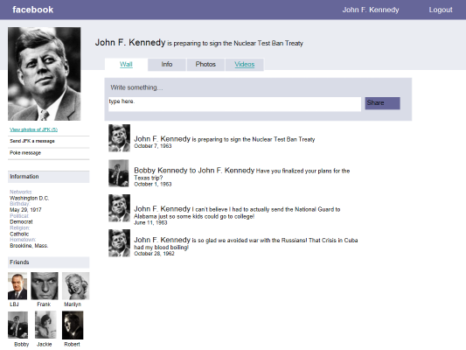

 | Rubric | Points
1 | Historical figure’s name, picture and Presidential number. | 5
2 | Historical figure’s hometown and relationship status. | 5
3 | What was his political party and religious preference? | 5
4 | Historical figure’s date of birth and death. | 5
5 | Include at least 2 additional pictures and where they moved to when they left office. | 10
6 | List four people that the historical figure would have been friends with on Facebook and add a picture of each person. | 20
7 | Include at least 5 items under Personal Information. | 10
8 | List one school he/she attended and one place he/she worked. | 5
9 | Write two wall posts the historical figure would have made. | 20
10 | Tell at least one important event that happened in the country during their presidency. | 20
11 | Write at least one wall post that one of his friends would have made. | 5

Research Information
Name___________________________________________ Presidential Number_____________

Hometown
Relationship status
Political party
Religious preference
Date of birth
Date of death
Friends (at least 4)
School attended
Previous career(s)
Possible wall post
Possible wall post
Possible wall post by a friend
Activities
Interests
Favorite Music
Favorite plays
Favorite books
Favorite food/beverage
Children
Where they moved to when they left office
What important event took place during their presidency

